|  |  |
| --- | --- |
| Course Name | ITD 2313 – Script Programming |
| Instructor | Prof M |
| Student Name | Pierre Tadong |
| Due date | 6/26/2022 |
| Grade |  |
| Grading Comments |  |

## Scope

### Page 192

1. In the middle of the page is a very small code example block showing the effects of scope.

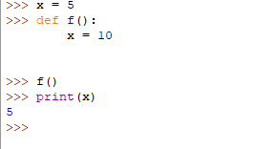

## Using Keywords for Default and Optional Arguments

### Page 194

1. An important note here is that the function that is used in this first code example block is actually on page 193 and will need to be entered.  Start this instruction set by entering that code on page 193 and then doing this first code example block on the top 1/4 of the page 194.
2. The second code example block is about 2/3 the way down on the page.  This also has a small definition of a function at the beginning of the code example block.

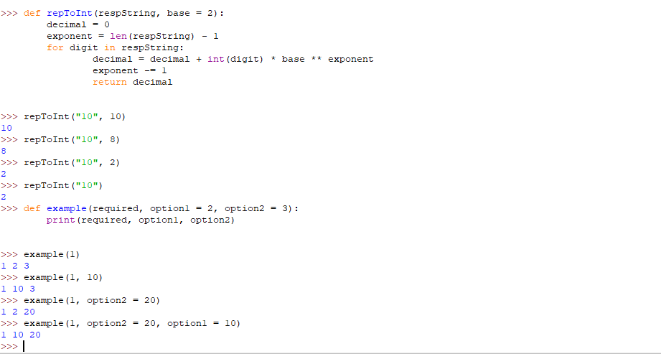

# Higher-Order Functions

## Functions as First Class Options

### Page 195

1. The code example block  is on the lower 1/3 of the page.

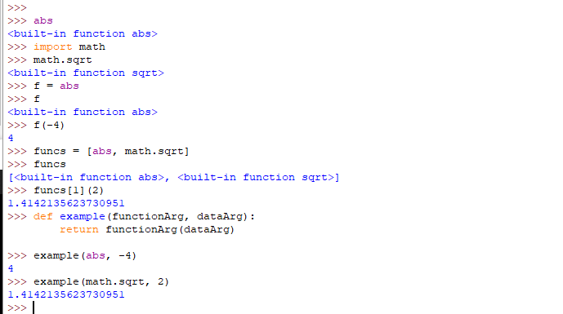

### Page 196

1. The first code example block is near the very top of the page before the new subsection on Mapping.
2. After the Mapping subsection begins about 1/2 way down the page, the second code example block can be found
3. The last code example block at the bottom of the page and is making some changes to the doctor program that is part of the chapter download.  It continues on the next page.  You should review and try this but do not need to take a screen shot of the work for this one.

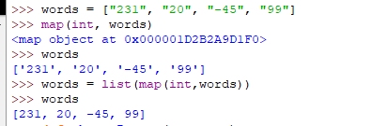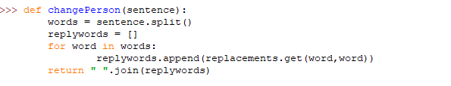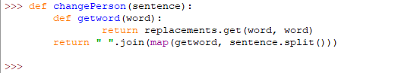

## Filtering

### Page 197

1. Just a little below the 1/2 point on the page is the code example block for this page that needs a screen shot captured.

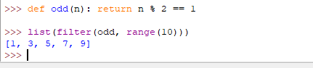

## Reducing

### Page 198

1. The first code example block is at the top of the page.
2. The second code example block is about 3/4 the way down on the page and deals with lambda.
3. The last code example block for this page is at the bottom.  It brings several of the concepts together into a single function.  It does not have a use of it in the example so you will need to write your own use of the function to show it works.

